**Functions**

|  |  |
| --- | --- |
|  |  |

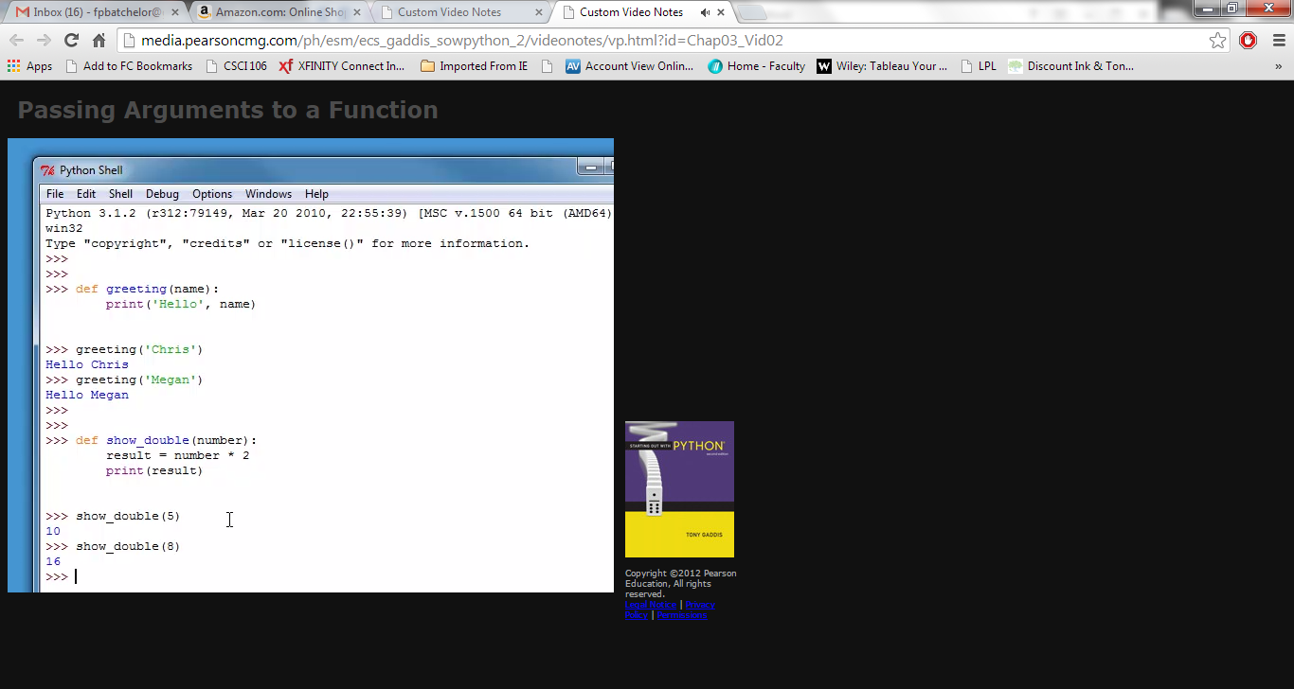

|  |  |
| --- | --- |
|  |  |

**Kilometer Converter Program (Kilometer into Miles)**

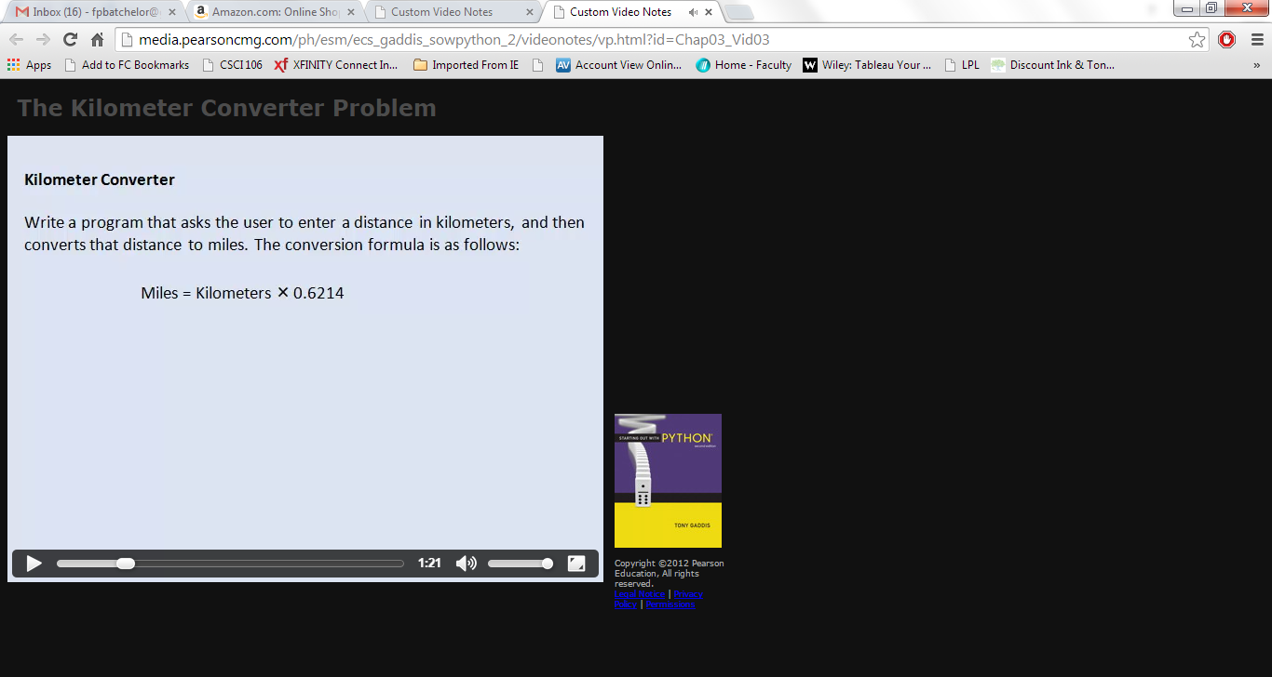

|  |  |
| --- | --- |
| **What it will look like when it runs:** |  |

|  |  |
| --- | --- |
|  |  |

|  |  |
| --- | --- |
|  |  |

